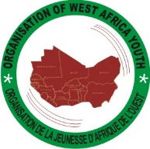

ORGANIZATION OF WEST AFRICA YOUTH

YOUTH LEADER RESPONSE TO COVID – 19 AND ITS SOCIAL IMPACT DIALOGUE VIRTUAL CONFERENCE

SUPPORTED BY

ECONOMIC COMMUNITY OF WEST AFRICAN STATES (ECOWAS)

Under the auspices of Youth, Sports and Development Center

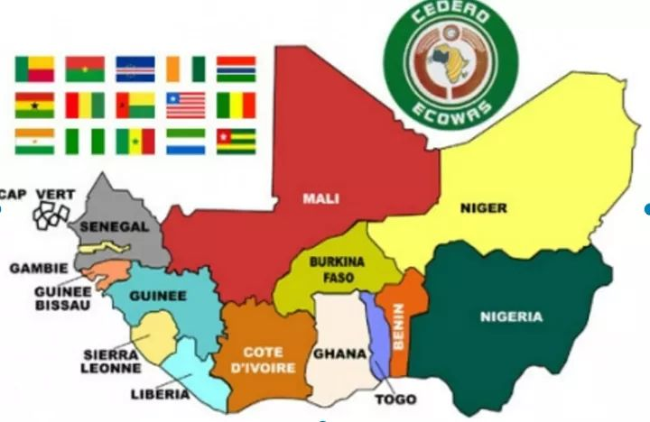Dated 26thJune 2020, 11:50AM, Abuja, Nigeria (Virtual Conference: Zoom)

Livestream on Facebook <http://www.facebook.com/WestAfricaYouthConference/>

Conference report – Summary

**Contents**

Acronyms

Introduction - - - - - - - - - -

Background - - - - - - - - -

Conference Objective - - - - - - - -

Participation - - - - - - - - -

Outcomes and results - - - - - - - -

**Opening**

* Dealing with the effects of COVID -19 on youth in West Africa
* What should be the new thinking of youth post COVID – 19 experience
* What should be the new trend towards work for young people
* The future of education for young people during and post COVID – 19
* Effect of integration on young people across West Africa during and post COVID – 19
* What should ECOWAS head of states and authorities do to assist young people during and post COVID –

Next Steps

References

Annex 1- Agenda

**Acronyms**

ECOWAS Economic Community of West African States Youth, Sports and

Development Center

OWAY Organization of West African Youth

And

ECOWAS Members States National Youth Institutions & Leaders

**Introduction**

This report summarizes the experience of the high-level regional virtual conference of ECOWAS Youth Leaders Response to COVID – 19 & it social impact, convened by the Organization of West Africa Youth (OWAY), with the support of the Economic Community of West African States Youth, Sports Development Center, the virtual meeting was hosted from Abuja, Nigeria on Friday, June 26, 2020.

**Background**

The virtual conference was geared toward national youth leaders and institutions across the Economic Community of West African States to share their thoughts, experiences and workings in the midst of Corona-virus pandemic, convened on Friday, 26th June 2020 in ECOWAS member states by the Organization of West Africa Youth and presided over by Mr. Kennedy Zaro Barsisa, Director of programme, Youth, Sports & Development Center of the Economic Community of West African States.

Since March 11, 2020, the World Health Organization (WHO) declared COVID – 19 as a pandemic, young people and Youth leader across West Africa have been so robust with awareness creation and providing health care assistance to contain the spread of the virus.

Many advances have been made towards the spread of the virus by young people. Providing effective leadership in such a critical time of COVID – 19 needed to be coordinated across the sub-region through awesome awareness raising and information exchanges.

However, implementation of the said coordination in ensuring that the virus is contained, mechanism must be designed for national youth institutions and organizations across the Economic Community of West African States taking into consideration gender equality to further develop strategies in the management of crisis response across the sub-region by the youthful population of West Africa.

This virtual conference was organized by the Organization of West Africa Youth with full cooperation and support by the Economic Community of West African States Youth, Sports   
Development Center.

**Conference Objectives**

The objective of the regional ECOWAS youth leaders’ virtual conference were:

* To provide a platform for discussion about the way in which ECOWAS youth leaders can share their thoughts, experiences and working in the midst of the coronavirus pandemic.
* To review policies and practices on youth employment and development generate ideas and recommendations for post to head of states and authorities of the Economic Community of West African States.

**Participation**

The virtual conference brought together the 15 member states of the Economic Community of West African States (ECOWAS) national youth leaders and youth institutions across the sub-region with 6 speakers (2 women and 4 men) representing Francophone and Anglophone countries in ECOWAS namely;

Cote D’Ivoire

Guinea

Mali

Liberia

Ghana

Gambia

**Outcomes and Results**

The virtual conference of youth leaders and institutions was the first of its kind to take place at a regional level with a key focus on discussing ECOWAS Youth Response to and its social impact. The ultimate objectives of the conference were to share experiences, inspire young people, build networks and take further responsive strategies in the management of the corona-virus pandemic crisis by young people across the sub-region in containing the spread of the virus and the responsibilities of young people across the sub-region.

The main outcome of the conference was a “joint call for regional action” for ECOWAS Commission support to National Youth Institutions across the sub-region, which covers the main recommendations emerging from speakers, participants and youth institutions of ECOWAS member states. This call reinforces a clear agenda for ECOWAS, governments, civil society, international partners and private public sectors to support and work with national youth institutions and leaders in order to have robust public awareness and information exchanges on the corona-virus pandemic in West Africa.

**Opening**

The virtual conference was opened by Uyero Erarawewho Jnr. Regional Coordinator Organization of West Africa Youth of the Federal Republic of Nigeria who welcomed the participants and reiterated young people commitment to the fight against the corona-virus pandemic.

He also expressed his appreciation to the Economic Community of West African States Youth, Sports and Development Center for the numerous supports and cooperation to the youthful population of West Africa and wished ECOWAS Youth leaders and institutions a healthy and productive deliberation exchange of ideas and information sharing about the pandemic.

Mr. Kenney Zaro Barsisa Director of Programme Youth, Sports and Development Center of the Economic Community of West African States ECOWAS, used his opening remarks to provide highlights on youth activities and the willingness of ECOWAS at all times to supports young people in the sub-region a demographic that remains an integral part of the commission. He reiterated the conference goal of sharing information and ideas on crisis management towards COVID-19, as part of efforts to support inclusiveness of young people in fight against the virus taking into consideration gender equality across West Africa.

On behalf of ECOWAS, he expressed thanks to all youth leaders and institutions of ECOWAS for their cooperation in making this virtual conference a reality, as part of efforts in building regional leadership in the fight against the Corona virus pandemic and strengthening the capacity of youth leaders and institutions in the sub-region.

**Dealing with the effects of Covid-19the pandemic on youth in West Africa**

The virtual conference began with a discussion about dealing with the effects of Covid-19 on youth in West Africa. The keynote speaker was Ms. Abena Attipoe of the Republic of Ghana, below is the summary of her presentation:

**Ms. Abena Attipoe, Republic of Ghana**

* We are today facing many challenges due to COVID -19 in West Africa as young people.

The effects of the pandemic on young people in West Africa can be placed into three (3) factors namely:

* Physical effect
* Emotional effect
* Economic effect

When we talk about effect, we are talking about the above mentioned challenges young people are currently going through as a result ofCoronavirus pandemic has created double burden of responsibilities, such as social protection, gender-based violence, food shortage, low income and poor entrepreneurship that have generated unemployment in maintaining stability.

Ms. Attipoe has promised to initiate a training project to support 20 youth organizations to engage into entrepreneurship, by increasing their access to ICTs creating virtual platform for cooperatives social businesses to provide cares for young people.

The presentation and discussions concluded on promoting young entrepreneurs for sustainable development and fight against gender-based violence, to ensure that young people are empowered and productive.

**What should be the new thinking of youth post experience?**

**Abdoul Mazid Barry, Republic of Guinea**

* There are so many obstacles facing the youthful population of West Africa, the challenges facing this demographic are so huge.
* The new thinking of youth Post experience must be providing policy opportunities for young people for inclusiveness in decision-making and the fight against the coronavirus pandemic.
* Young people must be actively involved in gender equality agenda advocacies, health care, effective governance, education and networking.
* Abodul Mazid Barrry emphasized networking in the fight against the coronavirus and appreciated young people in the sub-region for their hard work in providing awareness in containing the spread of the virus.
* The presentation and discussions concluded on promoting strong grass root youth organizations and support information and capacity development for young people in the sub-region.

**What should be the new trend towards work for young people?**

**Ms. Kaddy Jadama, Republic of the Gambia**

* The present situation of young people at various work places are challenging the coronavirus pandemic has affected young people in all sectors.
* Young people must develop concrete initiatives that target women in leadership at all level. Develop agenda that support youth employment and empowerment.
* Ms. Kaddy Jadama, emphasized care for young people with mental health conditions/illness and strong unity among young people across the sub-region. Ensure young people initiatives are improved to provide better services within various political, social and cultural lives.

The presentation and discussions concluded on promoting practical economic empowerment for young people and enhance their ability to self-livelihood opportunities.

**The future of education for young people during and post COVID -19**

**Adou Frederic, Republic of Cote D’lvoire**

* The Coronavirus pandemic has attracted our attention to things that are not working in our education systems in West Africa.
* It is time we adapt new mechanism especially technologies and civic engagement to our educational system in the Sub-Region. The Coronavirus has created a platform for ECOWAS head of states and authorities to invest in capacity building beyond the traditional system of education and bring in technologies.
* In West Africa, some of the challenges we are facing right now are civic engagement and responsibilities. Young people must be provided with opportunities and capacities to meet up the challenges in the educational sector in West Africa.

Adou Frederic, emphasized the use of technologies to improve on our traditional educational sector by looking into a well-structured digitalization. There will always be unforeseen circumstances which COVID-19 has caused today.

The presentation and discussions concluded on promoting digitalization in the Economic Community of West African States to prepare for unforeseeable future by putting up a well-structured system to save time and resources.

**Effect of Integration on young people across West Africa during and post COVID-19**

**Mohamed Salaha Koyrakoy, Republic of Mali**

* The corona-virus pandemic has created numerous problems of which; we as human/young people didn’t think about.
* Integration in West Africa has been affected due to COVID-19 cases in the region. The spread of the virus has created decline in human movements and interactions.
* The conference provides a new opportunity for young people to learn new ways of creating inclusive policies and working groups on mainstreaming youth activities.
* We must all reflect on how we can consider things that most often deprived young people in our decision-making causing inequalities that serve as one of the key factors to the integration process among the youthful population of West Africa.
* Mohamed Salaha Koyrakoy, emphasized strong regional support and collaboration from ECOWAS commission towards youth empowerment and engagement.

The conference discussion pointed face to face trainings and young people interaction although the virtual conference is important, but more physical engagement needed for young people learning and participating into dialogues on issues affecting them in sub-region to be addressed.

**What should ECOWAS head of states and authorities do to assist young people during and Post Covid-19?**

**Amos Williams, Republic of Liberia**

Thank you for joining us today on this virtual ECOWAS Youth leaders response to Covid-19 dialogue sponsored by the Hon. Director of Program, ECOWAS Youth, And Sports Development intended to share our various countries experiences on the fight against the corona-virus pandemic and to share key recommendations for head of states and authorities of the Economic Community of West African States ECOWAS.

The world is at the critical point in human history and there is no time like now for ECOWAS head of states and authorities to leave young people behind in the fight against the Global # COVID-19:

* Young people must be mobilized for communities, schools and other institutions for health services awareness.
* Ensure more cooperation and engagement in responding to COVID-19.
* A Coronavirus response fund must be established by ECOWAS Authorities to contribute financially in strengthening health institutions, science and technology and young entrepreneurs.
* The increase in youth unemployment as a result of COVID-19 is rising daily hardship targeted policy interventions must now be developed to ease financial impacts on young people and households.
* Special attention must be given to adolescent girls and young women, young people with disabilities, young people with different sexual and gender identities, young people with physical or mental health conditions, young people living with HIV/AIDS and homeless youth.

Amos William, emphasized that social policies must be developed to address youth vulnerabilities and which will drive innovation and contribute to economic dividends.

The presentation and discussions concluded on promoting youth education, entrepreneurship, employment, environment, and adequate health care in the sub-region.

**Next Steps**

The virtual ECOWAS youth leaders response to COVID-19 and its social impact dialogue virtual conference provided an opportunity for the Economic Community of West African States Youth, Sports And Development Center, Organization of West Africa Youth and national Youth institutions across the sub-region firsthand information on wide range of issues affecting young people throughout the member states of ECOWAS. The conference collected statistics on gender, youth representation, in decision-making at national, regional and local levels; and the effects of the coronavirus pandemic on young people.

ECOWAS youth leaders and participants highlighted the need for common effort in containing the spread of the virus and ways forward for youth empowerment and development. Through technical meetings held within group work and discussions at the conference, ECOWAS youth leaders produced this brief document which summarizes key issues that were discussed and recommendations for areas of action for the Economic Community of West Africa States ECOWAS, governments, international partners and civil society groups. This report was reviewed by ECOWAS youth leaders chaired by Mr. Kennedy Zaro Barsise of ECOWAS Youth, Sports and Development Center and Co-chaired by Uyero Erarawewho, Regional Coordinator Organization of West Africa Youth and was unanimously adopted.

The virtual conference was closed by Mr. Kennedy Zaro Barsise Director Programme Youth, Sports and Development Center.

The closing remarks, it was emphasized that ECOWAS Commission began to fully address youth representations at the commission by setting up Desk Officers in all its member states. The conference was an excellent platform for networking, information gathering and sharing experiences from all member states of the ECOWAS.

Additional information on the conference can be located on the event Facebook page <http://www.facebook.com/West>Africa Youth Conference.

**References**

Economic Community of West African States Youth, Sports And Development Center Ouagadougou, Burkina Faso,

Abuja, Nigeria

[kzbarsisa@ecowas.int](mailto:kzbarsisa@ecowas.int)

Organization of West Africa Youth, Abuja, Nigeria

<http://www.owayouths.org/>

**Annex 1 – Agenda**

Agenda

ECOWAS Youth Leaders Response to COVID-19 And its Social Impact Dialogue Virtual Regional Conference

Abuja, Federal Republic of Nigeria

Friday, 26th June 2020

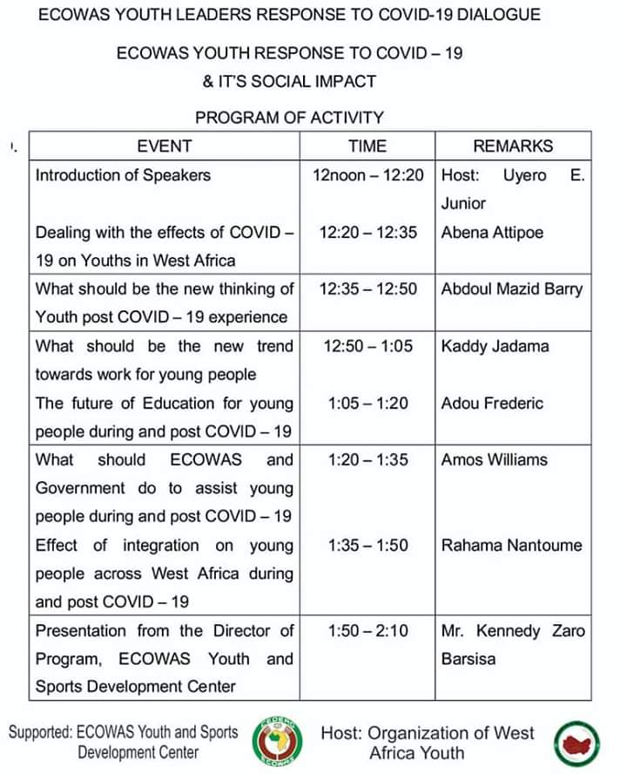

Agenda

**Annex 2 –**Participants was online

ECOWAS Youth Leaders Response to COVID-19 and it Social Impact Dialogue Virtual Conference

Abuja, Federal Republic of Nigeria

Friday, 26th June 2020